Thread consumption
Sewing thread is ordered before the actual production starts. The thread amount is estimated according to fabric, stitch type, machine type and thickness of layers. Mostly the thread consumption is theoretically calculated based on the type of type of stitch with respect to the length of the stitches required. In general 10% wastage is added considering the fabric thickness not exceeding 2mm.
The details of thread consumption per inch for each type of stitch is mentioned below.

- Single Needle Plain Machine needs 2.75 inches thread for per inch stitch
- 2 Needles Plain Machine = 5.5 inches for per inch stitch
- 3 Threads Over lock Machine = 15 inches thread for per inch stitch
- 4 Threads Over lock Machine = 19 inches thread for per inch stitch
- 5 Threads Over lock M/c = 23 inches for per inch stitch
- Safety Stitch = 20 inches for per inch stitch
- Flat lock Stitch = 32 inches for per inch stitch
- 2 Needle Kansai M/c = 12 inches for per inch stitch
- 1 Needle Chain Stitches = 5 inches for per inch stitch
- Feed of the Arm M/c = 11 inches for per inch stitch
- Button Hole = 24 inches for per inch stitch
- Bar take M/c = 26 inches for per inch stitch
- Button Stitch of 2 Eyes (holes) = 3 inches thread
- Button Stitch of 4 Eyes (holes) = 6 inches thread
Question 1. A shirt having 104 inches 4 Threads Over lock stitches, 52 inches Flat lock stitches, 20 inches 1 Needle Chain stitches, 15 inches Single Needle Plain Machine stitches, the fabric thickness is less than 1mm, find out its thread consumption in meters?
Answer:

Question 2. Suppose, we want to buy thread cones with 2000 meters thread, now figure out how many cones do we need, to stitch 3000 pieces of garments, per garment’s thread consumption 106.71 meters?
Question 3. A garment requires 90 inches of 2 needle kansai machine, and 50 inches of 1 needle chain stitch. Calculate thread consumption for 1 shirt in Meters

Question 4: A shirt required 15 buttons( 2hole button) and 8 ( 4 hole button), each button hole required 1 Inch of stitch length. Calculate thread consumption for thread.
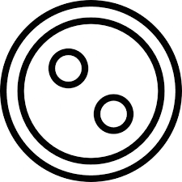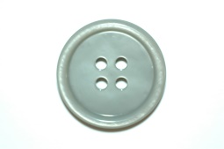

{(104 x 19) + (52 x 32) + (20 x 5) + (15 x 2.75) + 10%} / 39.37 = 106.71 Meters. (39.37 inches = 1 Meter)

106.71 x 3000 / 2000 = 160 cones.

A garment requires 90 inches of 2 needle kansai machine, and 50 inches of 1 needle chain stitch. Calculate thread consumption for 1 shirt in Meters
((90*12)+(50*5)+10%)/39.37.=
1080+250+10%/39.37
1463/39.37
37 meters

