Name:
Count refers to the thickness of a yarn and is determined by its mass per unit length. It is usually measured by the number of grams per one kilometer of yarn, a unit of measure called “Tex”.
>>>>>>>>>>>.Tex: No. of grams per 1'000 meters<<<<<<<<<<<<<<
PROBLEM 1: Calculate thread count TEX of the provided thread.
- Cut the thread of 10meter ( do it 5 times)
- Measure the Grams of each thread on measuring scale
- Calculate TEX, ( do not forget to convert meter to km)
(Cut 10 meter of the provided sewing thread and weigh it on a scale and calculate number of grams for 1 kilo meter)
 | 1 | 2 | 3 | 4 | 5
Grams
Tex
PROBLEM 2: Use the following table to convert the thread count in to different measuring units around the world.
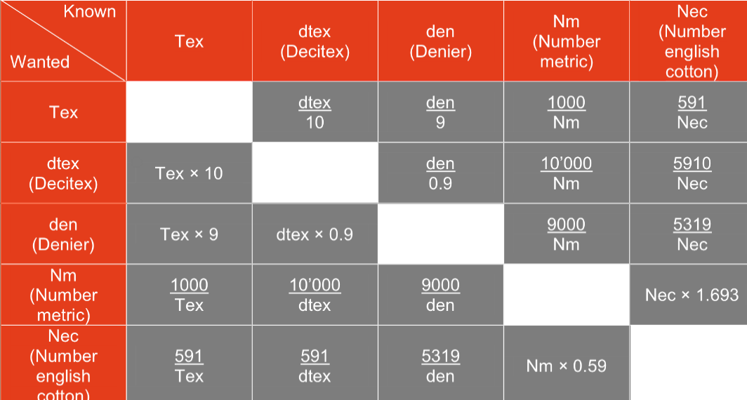
Tex
Tex
Deci Tex
Denier
Number Metric
Number English Cotton

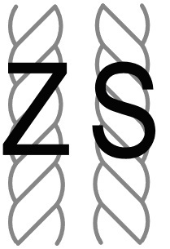
PROBLEM 3: Check if the thread is Z or S twist?

