Exercise 2
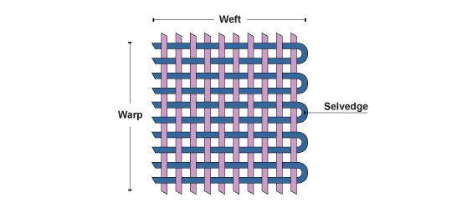
Name:
- Cut 3 sample to size of 10*10cm, (do not cut from the edges)
- Count number of warp and weft yarn in 1 cm
- Calculate crimp percentage for warp and weft.
The crimp percentage is the difference between straightened thread length and the distance between the ends of the thread in the fabric.
Formula for Crimp percentage
Crimp % C = (L-s)/s x 100
L= measured length of warp/weft
S= measured length of cloth that is 10cm
C= crimp percentage

Measurement | Number of warp/cm | Number of weft/cm | Warp crimp% | Weft Crimp %
1
2
3

Exercise 2 Name:
- Cut 3 sample to size of 10*10cm, (do not cut from the edges)
- Count number of warp and weft yarn in 1 cm
- Calculate crimp percentage for warp and weft.
The crimp percentage is the difference between straightened thread length and the distance between the ends of the thread in the fabric.
Formula for Crimp percentage
Crimp % C = (L-s)/s x 100
L= measured length of warp/weft
S= measured length of cloth that is 10cm
C= crimp percentage
Measurement | Number of warp/cm | Number of weft/cm | Warp crimp% | Weft Crimp %
1
2
3

