Exercise 1- Clothing Technology
Woven fabric (like denim jeans, dress shirts etc.) are made from WARP and WEFT yarn.
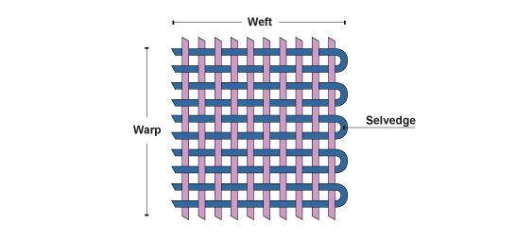
TASK: Calculate number of warp and weft yarn in 1 meter of fabric

How to do:
Cut sample 10*10cm (do not cut from the edges of the fabric)
Count number of yarns in 1 cm for both warp and weft
Warp is BLUE and WEFT is WHITE in color.
Measurement | Number of warp/cm | Number of weft/cm | Warp in 1 meter | Weft in meter
1
2
3

