Marker:
It is precise arrangement of pattern pieces (digital or printed) to be cut from the fabric spread.
Marker efficiency:
(Area covered by patterns/ total area of the fabric) *100
Low marker efficiency shows more fabric is wasted.
Marker Plan
The orders of garments contain different SIZES and need to be cut from same marker. The sizes are usually ordered in different quantities and needs marker planning.
ASSORTIE
Number of unique garments (all pattern of each size) to be included in the marker plan.
e.g what is marker plan for
500 polo shirts are required in which SMALL size: 100, MEDIUM size 200, and LARGE size: 50.
Step 1: the number of layers will be equal to the minimum pieces required for any garment, in this case it is 50
Step 2: calculate how many times each garment pattern has to repeat n the marker, in this example the garment pattern will be placed on the marker following time
L= 1 time
M= 4 times
S= times.
There is no need for another marker all garments can be cut form 1 marker and 1 times spread plan

Questions:
- Calculate the marker efficiency. Total area of the garment patterns are 5.78m²
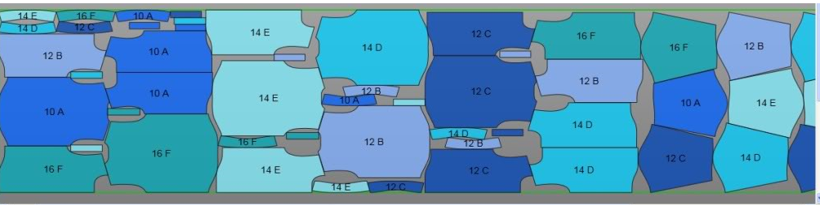
6.1 m
1.2mm
- See the customer order amount below and then calculate the necessary information
XS | S | M | L | XL | XXL
50 | 100 | 200 | 200 | 100 | 50
- What is the assortie of the order how many pieces of the garment will be on the marker plan?
- How many layers of the fabric will be necessary?
- How much meter of the fabric is necessary for total production ( the length of the marker plan is 7.25 m)
- Calculate the fabric cost of one garment, considering all pieces are similar dimension. (fabric price is 1.2 €/m)?

- See the customer order below and calculate how many marker plan is necessary and how many layers required for each marker plan?
XS | S | M | L | XL | XXL
100 | 160 | 240 | 230 | 150 | 90
4) See the customer order below and calculate how many marker plan is necessary and how many layers required for each marker plan?

XS | S | M | L | XL | XXL
120 | 94 | 220 | 280 | 450 | 670

