

**Task 1 – Determining the hue of samples in the NCS atlas and determining the color difference E* between the subjective assessment and the objective measurement**

**Name:**

**Date:**

**Year and branch of study:**

**Task:** fill in

**Instruments:** fill in

**Tools:** fill in

**Laboratory condition:** fill in

**Procedure:** fill in, briefly describe

**Elaboration:** Put the results in tables, graphs, figures, and calculations and describe them. You will have one table for each type of illumination. The table must be all on one page.

|  |  |  |  |
| --- | --- | --- | --- |
| **Illumination – simulator D65** | | | |
| **Sample** | **Evaluation** | **Code** | **E\*** |
|  | *Visual assessment* |  |  |
| *Measurement\** |  |  |
|  | *Visual assessment* |  |  |
| *Measurement\** |  |  |
|  | *Visual assessment* |  |  |
| *Measurement\** |  |  |

* If you have assigned the sample correctly, complete this section in the same way as the visual assessment. If the database assigned a different nearest sample, enter the code of this sample and its color difference.

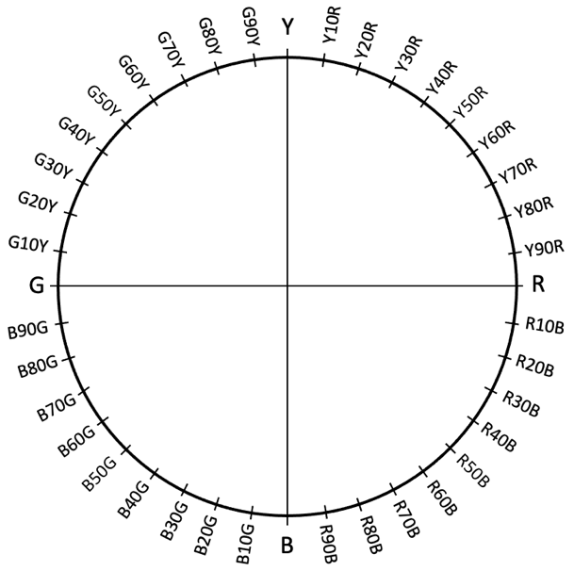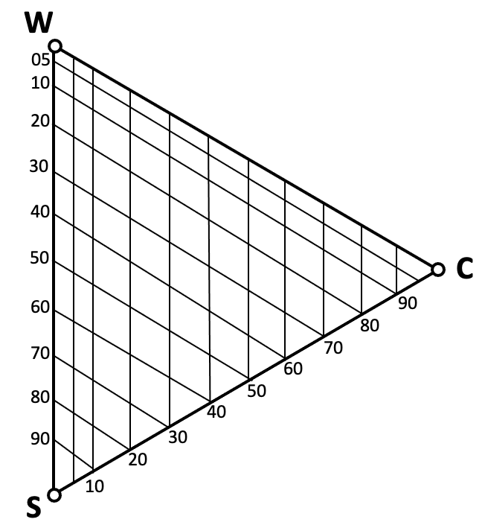NCS atlas

Pantone

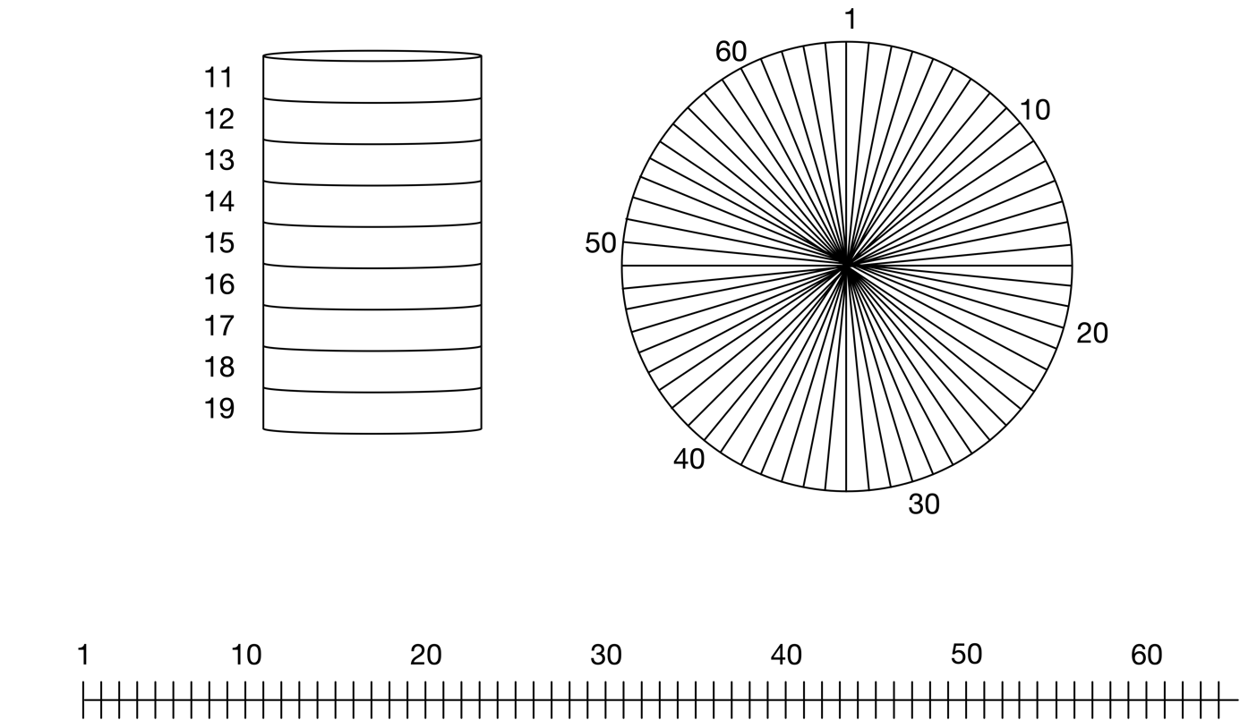

**Conclusion:**

Discussion of the results and answering the questions in the task.