A1BH Lesson 2
- Any questions – presentations in wiki – Tuesday’s group – why in Czech?

Packaging – an uncountable noun (obaly), to pack –sbalit (věci do zavazadla)/ to package – zabalit, dát do balíku, a pack, a package – balík, balíček
Page 36 – discussion 1 in pairs
Shapes – the word document in Moodle (How to describe shapes, colours)
Kahoot - (Names of 3D shapes)
Pictures of different products/ packaging – describe the shape, material, your opinion
1.
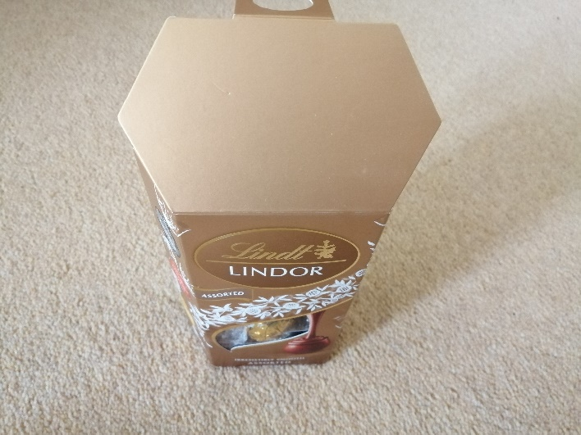
2.
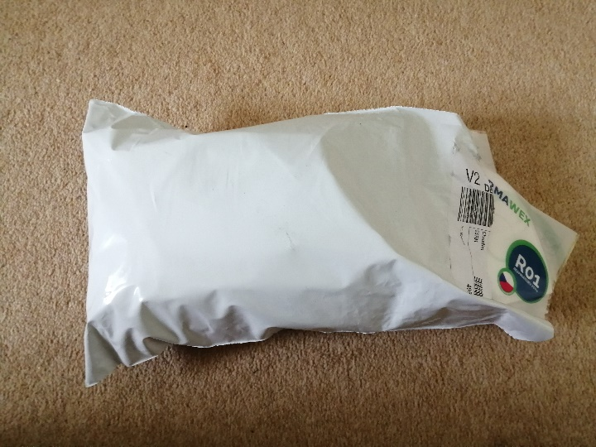

3.
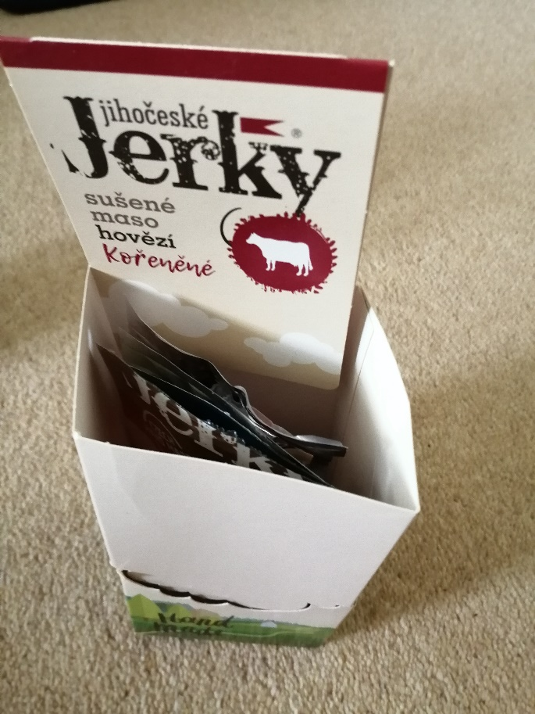
4.
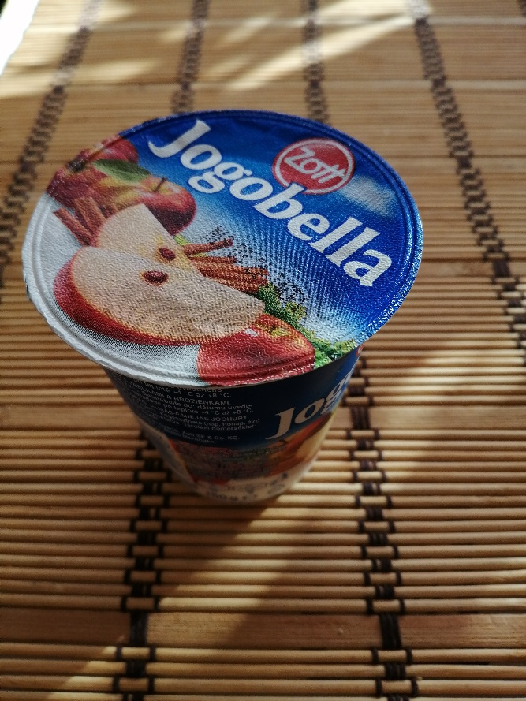

5.
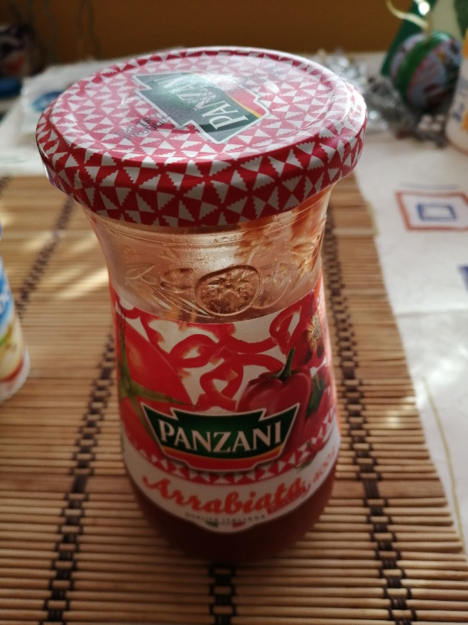
6.
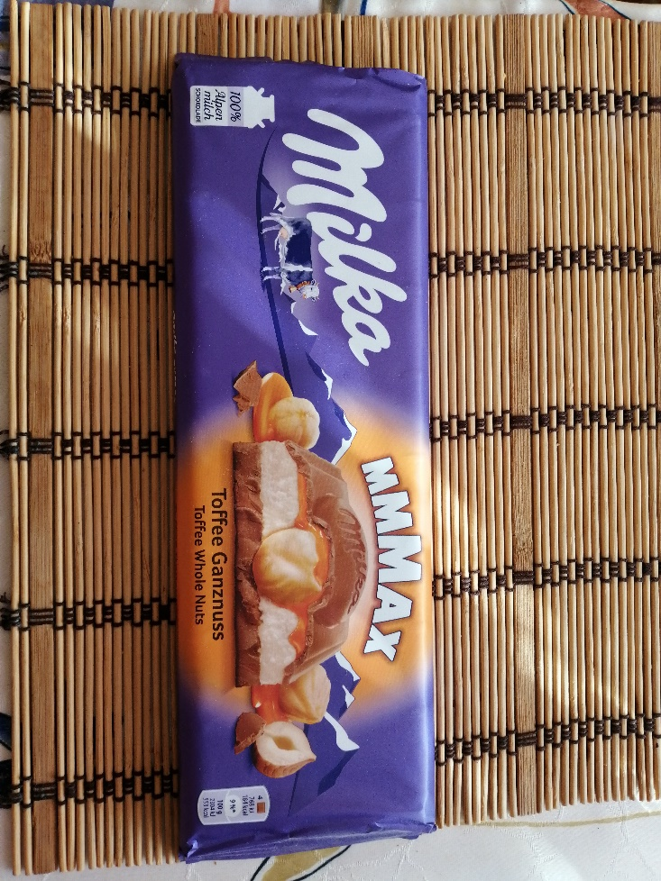

7.
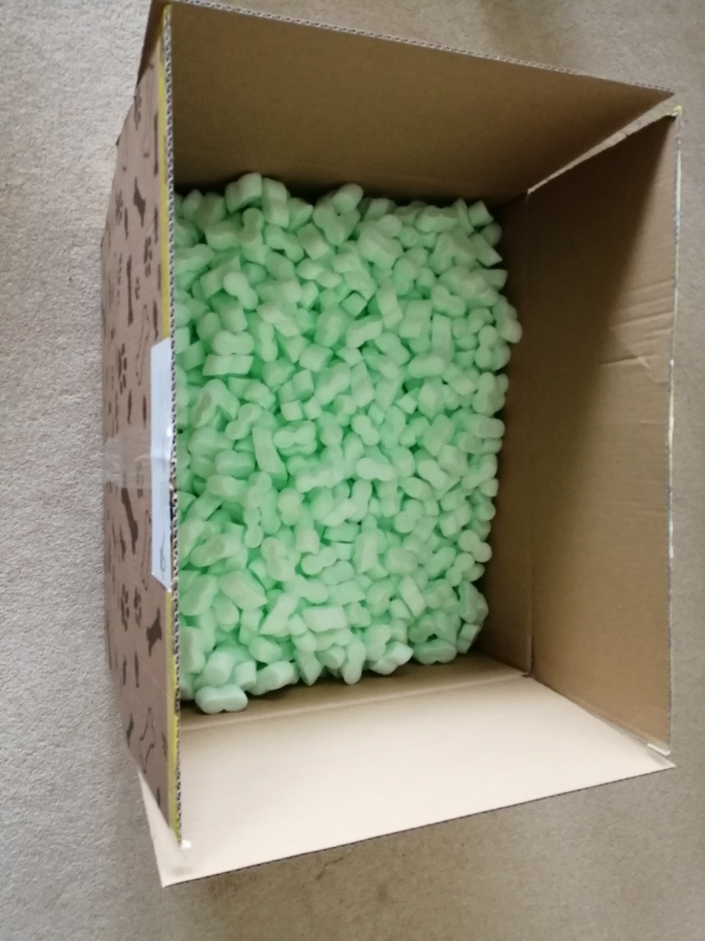
Listening 1:28 – exercises 36/2,3
Seduce – svést
Purchasing decision – rozhodnutí o nákupu
Lack of communication
A task force – cross-functional team
They lock them
Branding, funding, schedules, manufacturing, designers
At the point of sale

About the article – 37/5,6
Words to remember

