**Teaching vocabulary**

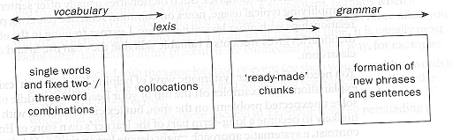

1. **Vocabulary → lexis → grammar:** (Srivener, J. 2011. *Learning Teaching*. Oxford: Macmillan Publishers.)
2. **What is involved in knowing a word? (**Nation, P., 2001, Learning Vocabulary in Another Language, Cambridge UniversityPress: Cambridge, p. 27)

|  |  |  |
| --- | --- | --- |
| **…** | **…** | **…** |
| What does the word sound like?  How is the word pronounced?  What does the word look like?  How is the word written and spelled?  What parts are recognizable in the word?  What word parts are needed to express the meaning? | What meaning does this word form signal?  What word form can be used to express this meaning?  What is included in the concept?  What items can the concept refer to?  What other words does this make us think of?  What other words could we use instead of this one? | In what patterns does the word occur?  In what patterns must we use this word?  What words or types of words occur with this one?  What words or types of words must we use with this one?  Where, when, and how often would we expect to meet this word?  Where, when, and how often can we use this word? |

1. **Teaching vocabulary:**

1) by means of teacher-fronted (teacher-centered) elicitation or explanation.

2) by means of a student-centred vocabulary task

3) by getting students to work out the meaning of new words they find in a text using the context.

**⇒ Task1: Existuje celá řada způsobů jak sdělit žákům význam slova. Přiřaďte tyto způsoby *a – h* ke slovíčkům *1 - 8*, které je třeba vysvětlit:**

1. hop (v)

2. viability (n)

3. exhausted (adj)

4. kiwifruit (n)

5. bitter (adj)

6. imitate (v)

7. skyscraper (n)

8. rarely (adv)

a. Showing students a physical object of some kind –sometimes called ‘realia’.

b. Doing a mime or action.

c. Explaining the meaning by giving an oral definition of the word.

d. Asking students to think about the opposite meaning of a word they already know.

e. Using a diagram.

f. Using a picture of something.

g. Telling a short, personal story to give an example of the meaning.

h. Getting students to read a short written text that acts as a context for the word.

1. **Presentation of words:** (Brewster, J., G. Ellis, & D. Girard. The Primary English Teacher´s guide. Pearson Education, 2002, p. 86-87)
2. Grouping: Lexical sets, Rhyming sets, Color sets, Grammatical sets, Partners, Collocations
3. Demonstration: using objects - drawings, illustrations, pictures, flashcards - actions, mimes

pointing, touching - using technology

1. Verbal techniques: Explaining, Defining context, Eliciting, Describing, Translating:
2. **Vocabulary practicing:** Mechanical practice → Communicative practice:
3. **Concept questions:**

**⇒ Task 2: Pročtěte si následující rady, které se týkají „concept questions” a rozhodněte zda jsou správné.**

1. „Do you understand ?“ není dobrá otázka a měli bychom se jí vyhnout.
2. Pokus vysvětlíte slovo do detailu není nutné klást „concept questions“.
3. Pokud je to možné, vždy se vyplatí připravit si „concept questions“ napřed.
4. Není vhodné používat slovník v případě, že byly použity „concept questions“, protože definice by mohly žáky mást.
5. Jestliže žák zopakuje po učiteli slovo, není nutné již klást „concept questions“ .
6. „Concept questions“ musí být jednoduché, ale konkrétní, spíše než příliš obecné.
7. Je dobré vysvětlit všechny významy slova najednou.
8. Odpovědi na „concept questions“ by měly být co nejkratší.

**⇒ Task 3: Concept questions:**

fade (adj)

question 1: If something fades, does it become more or less clear? (less clear)

question 2: Does this usually happen quickly or slowly? (usually slowly)

question 3: Can colours in clothes fade? (yes)

question 4: Do clothes designers like colours that fade? (not usually)

a. embarrassed (adj)

question 1:

question 2:

question 3:

b. mope (v)

question 1:

question 2:

question 3:

c. barracks (n)

question 1:

question 2:

question 3:

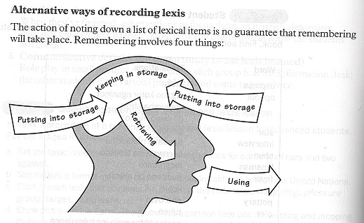

1. **Remembering words:**

(Srivener, J. 2011. *Learning Teaching*. Oxford: Macmillan Publishers.)

Three commonly used techniques for vocabulary instruction are:  
1.**the association method**   
2.**the category method**   
3.**the dictionary method**

1. **Visual association:**



**2. The category method:** Match the lists of words with the categories below:

Money in your pocket

Things you put money in

Money you are paid

Poor

You have to pay these

Rich

1. a bill / a fare / a fine / a fee
2. cash / change / coins / notes
3. a safe / a slot machine / a piggy bank / a till
4. wealthy / affluent / prosperous / well-off
5. wages / earnings / pay / salary
6. impoverished / broke / poverty-stricken / penniless

**3. The dictionary method:** How to Read an Etymology

L ***transmittere*** to send across = *trans-* TRANS- + *mittere* to send.

1. **Pra****ctical recommendations for vocabulary teaching**

* Give your students a few vocabulary items. Tell them to find their meaning, pronunciation and ask them to write a sample sentence with the word in.
* Prepare worksheets and ask your students to match words to definitions.
* Ask students to classify a group of words into different categories (so-called semantic fields).
* Ask students to find new vocabulary from reading their homework. They can teach each other in the class.
* Review the vocabulary you teach through a game or activity and encourage your students to do the same at home.
* Encourage autonomy in your learners. Tell them to read, watch films, listen to songs, etc. and point out useful words.
* It is a good idea to teach/learn words with similar meanings together, but only in case of more advanced students.
* Encourage your students to buy a good dictionary and use class time to highlight its benefits.
* Teach your students grammatical names for the parts of speech and the phonemic script of words.
* Always keep a good dictionary by your side in case a student asks a word you are not sure about.
* If you have never heard of the word, tell the student you will check and get back to them. Do get back to them.